Name: Pranali Sonawane
Subject: CCNA
Date: 11-11-2025
Lab – Router Information Protocol(RIP):
First, we have taken three routers, three switches, and three PCs.The routers are connected to each other using serial cables.Each router is connected to a switch using a straight-through cable, and each switch is connected to a PC using a straight-through cable.
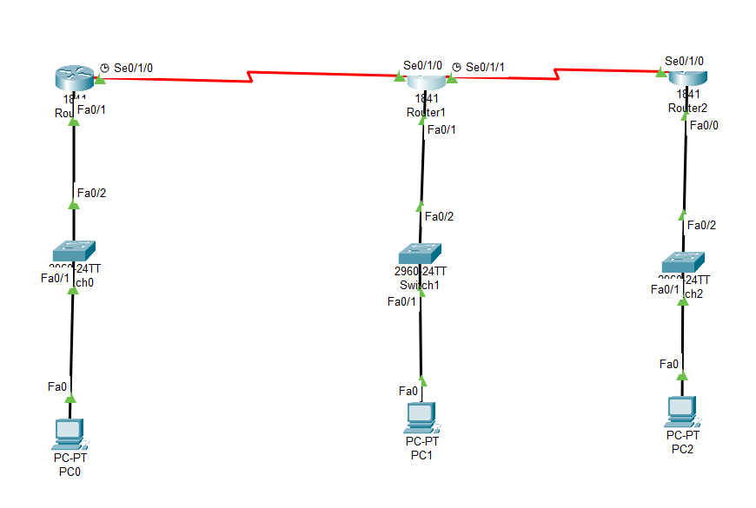
Configure PCs :
- PC0:
  - IPv4 Address: 10.0.0.2
  - Subnet Mask: 255.0.0.0
  - Default Gateway: 10.0.0.1
- PC1:
  - IPv4 Address: 20.0.0.2
  - Subnet Mask: 255.0.0.0
  - Default Gateway: 20.0.0.1
- PC2:
  - IPv4 Address: 30.0.0.2
  - Subnet Mask: 255.0.0.0
  - Default Gateway: 30.0.0.1
Open Router 0 – CLI prompt then type following commands
Router>enable
Router#configure terminal
Router(config)# interface fastEthernet 0/0
Router(config-if)# ip address 10.0.0.1 255.0.0.0
Router(config-if)#no sh
Router(config)# interface serial0/1/0
Router(config-if)# ip address 40.0.0.1 255.0.0.0
Router(config-if)#no sh
Router(config)# show ip route
Router(config)#router rip
Router(config-router)#version 2
Router(config-router)#network 10.0.0.0
Router(config-router)#network 40.0.0.0
Router(config-router)#exit
Router(config)#exit
Router(config)# show ip route

Open Router 1 – CLI prompt then type following commands
Router>enable
Router#configure terminal
Router(config)# interface fastEthernet 0/0
Router(config-if)# ip address 20.0.0.1 255.0.0.0
Router(config-if)#no sh
Router(config)#exit

Router(config)# interface serial0/1/0
Router(config-if)# ip address 40.0.0.2 255.0.0.0
Router(config-if)#no sh
Router(config)#exit

Router(config)# interface serial0/1/0
Router(config-if)# ip address 50.0.0.1 255.0.0.0
Router(config-if)#no sh
Router(config)#exit

Router(config)# show ip route
Router(config)#router rip
Router(config-router)#version 2
Router(config-router)#network 20.0.0.0
Router(config-router)#network 40.0.0.0
Router(config-router)#network 50.0.0.0
Router(config-router)#exit
Router(config)#exit
Router(config)# show ip route

Open Router 2 – CLI prompt then type following commands
Router>enable
Router#configure terminal
Router(config)# interface fastEthernet 0/0
Router(config-if)# ip address 30.0.0.1 255.0.0.0
Router(config-if)#no sh
Router(config)#exit

Router(config)# interface serial0/1/0
Router(config-if)# ip address 50.0.0.2 255.0.0.0
Router(config-if)#no sh
Router(config)#exit

Router(config)# show ip route
Router(config)#router rip
Router(config-router)#version 2
Router(config-router)#network 30.0.0.0
Router(config-router)#network 50.0.0.0
Router(config-router)#exit
Router(config)#exit
Router(config)# show ip route

